ESD (Employability Skills Development) FA-1

Title:

Design database with 2 tables at least having 5 columns minimum for the project allocated – Expense Tracker App

**Tools:** Microsoft Word, PhpMyAdmin

**Screenshot:**

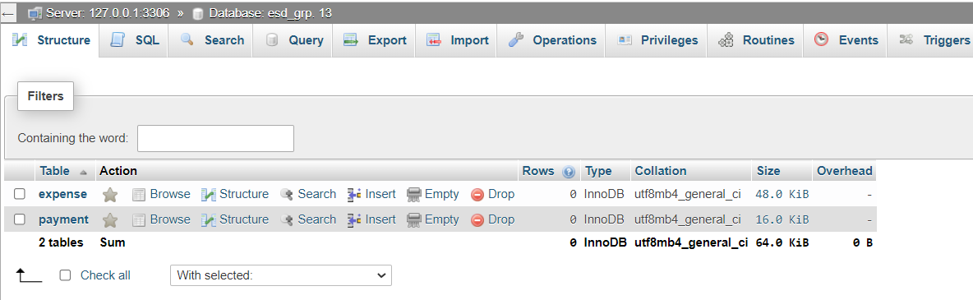 **Database Design**

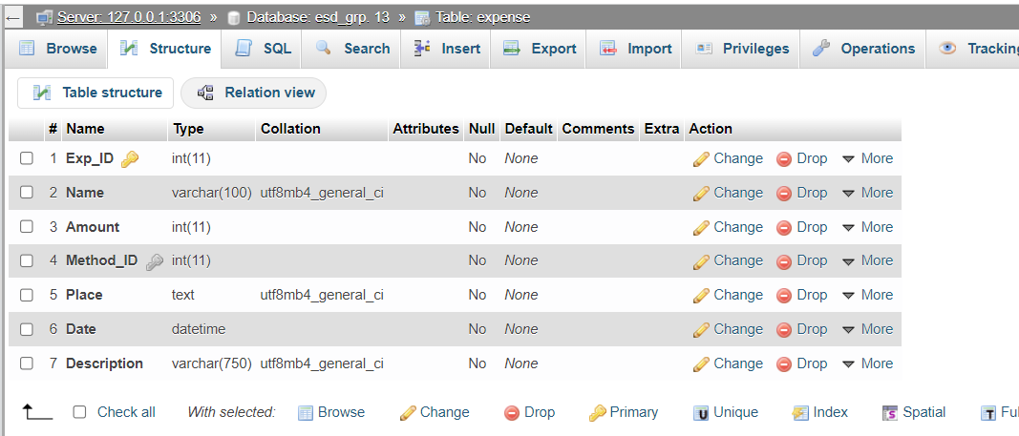 **Table 1: Expense**

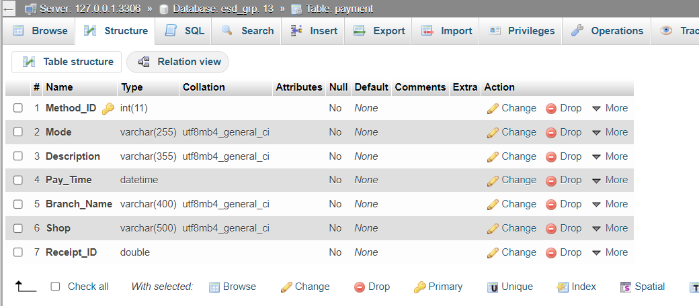 **Table 2: Payment**

So, for our project that is Expense Tracker App we have designed a database with the name ‘esd_grp. 13’ This database design allows for tracking detailed information about each expense, including the name of the purchased item it belongs to, the payment method used, and the shop or mall where the expense was made. Flexibility for adding, updating, and removing is provided via the foreign key relationship with the payment table. This table stores the information such as the date of the expense made along with the creation and update of the timestamps. It also contains a breakdown of the cost as well as any further remarks or observations. Overall, the expense table lays the groundwork for all reporting and analysis of the user's spending patterns, making it a crucial component.

The Payment table stores information about the different payment modes used by the user, including an Method_ID, the user who created the payment mode, the name and description of the mode, the bank account through which the transaction is made, and the creation and update timestamps. Information about the various payment methods that a user can use to make costs would be kept in the Payment Mode table. In addition to allowing the app to give insights and data on which payment methods are most commonly used and how much money is spent using each one, this can assist users rapidly recognize and choose the right payment option when making an expense.